Escape Room GDD

# Document History

| Version | Date | Changes |
| --- | --- | --- |
| 1.0 | 16-03-2022 | Initial Details |
| 1.1 | 17-03-2022 | MDA, USP, Theme and Mood |

# General Overview

| Category | Educational Game |
| --- | --- |
| (Practice) Goal | To make teaching interactive through digital gaming |
| Target Audience | 16 - 20 year olds students |

# Elevator Pitch

A 2D, quiz-based, escape room education game that has adaptive visuals and puzzles and can be played on the internet by multiple people using their phones or laptops.

# Game Summary

An adaptive escape room game where it is integrated with a management tool so that teachers can input questions and the game’s visuals and puzzles change accordingly. Once a room is created, a room code is generated and students can use the code to join the game and solve the puzzles/challenges that were laid by the teacher by working together.

# 

# Play Session

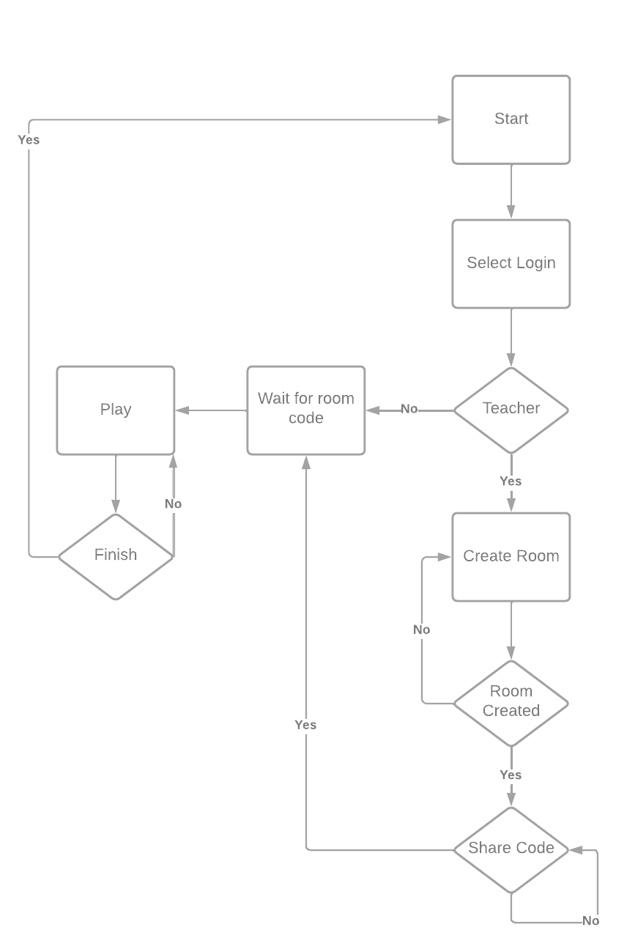

# MDA

## Mechanics

* Adaptive puzzle/challenges
* Adaptive visuals
* Multiple Choice puzzles/challenges
* Quiz-based puzzles/challenges
* Drag-and-drop puzzle system/Card-based puzzle system
* Room Code
* Highscores
* Multiplayer system (up to 4 people)

## Dynamics

* The level/room adapts based on the input given by the teachers
* Puzzles are solved by clicking and dragging at objects
* Students can play the same room by sharing room code
* Students performance are judged based on the scores

## Aesthetics

* Adaptability means that a room can be used for multiple educations
* Multiplayers allows students to work together finishing a room
* Performance can be judged easily by the score system

## USP

* Digital Escape Room
* Adaptive Puzzles/Challenges
* Playable on handheld devices
* Multiple players

## Theme and Mood

**Theme:**

* ROC Tilburg: The visuals and colors will follow the branding guide from ROC Tilburg in addition to one more color (Yellow most likely) to create better contrast.

**Mood:**

* Challenging: Challenges the students to work outside of the box to solve the room together.